**Exciton Diffusion and FRET in Dye-doped Conjugated Polymer Nanoparticles**

Louis C. Groff, Xiaoli Wang, and Jason D. McNeill

**Abstract**

The fluorescence properties of perylene red doped PFBT nanoparticles were investigated by steady state and time-resolved fluorescence spectroscopy. Highly efficient energy transfer at low doping percentages is seen in the spectra and evidenced in the time-resolved measurements. The time-resolved measurements were simulated using a combined exciton diffusion/energy transfer model coupled with Poisson statistics. The hypothesis that the reduction in quantum yield of conjugated polymer nanoparticles is due to defects which arise as the nanoparticle forms has been evidenced by the optical properties of both PFBT in good solvent and PFBT nanoparticles. This has also been implemented in the modeling parameters. The results of the exciton diffusion/energy transfer simulations yield an exciton diffusion length of 12 nm for PFBT, which has promising implications for polymer-based photovoxltaics.

**Introduction**

In recent years, there has been a great deal of interest in conjugated polymers, largely due to their application as the active materials in flexible, low-cost, highly efficient photovoltaic1 and light-emitting devices.2 Conjugated polymer nanoparticles (CPNs) are of interest for use in biological imaging, given their high fluorescence brightness, extraordinary two-photon fluorescence cross-sections, and excellent photostability.3-9 It is increasingly clear that further development of applications requires additional understanding of the complex photophysics and photochemistry of conjugated polymers, as well as their sensitive dependence to polymer structure and processing conditions. In organic semiconductors, the principal neutral electronic excitation of interest is typically the collective, Frenkel-type singlet exciton.10,11 Energy transfer between chromophores occurs via multiple processes, including incoherent, diffusion-like processes,12-14 and in some cases, via ultrafast, long range coherent transport.15 In the incoherent picture, each polymer chain is considered to consist of several more or less independent chromophores, and excitations transfer from one chromophore to other nearby chromophores via transition dipole-mediated Förster transfer.16 Multiple excitation transfer events typically occur during the excited state lifetime, resulting in a random walk-like process characterized by a diffusion constant or diffusion length. A large exciton diffusion length is required for optimum photovoltaic device efficiency (for some device geometries), since excitons must travel to the heterojunction, where charge separation occurs. While the exciton diffusion length in high purity, crystalline inorganic semiconductors can reach several microns,17 it is typically much shorter for organic semiconductors. For example, measured exciton diffusion lengths for single crystals of anthracene range from ~30 nm to 60 nm,18-20 and diffusion lengths of under 15 nm are typically reported for conjugated polymers.21-23 Interacting chromophores can also give rise to aggregate species such as dimers, H- and J-aggregates, excimers, and exciplexes.24,25 Energy transfer can also occur to these and other species such as excess charges (polarons), defects in the polymer, or dopant species such as dyes and other polymers. These processes can significantly reduce the exciton diffusion length.

Various experimental approaches have been pursued for characterizing exciton diffusion, including photoluminescence quenching in layered structures,12,26 confocal fluorescence microscopy,27 near-field fluorescence microscopy,28-30 time-resolved fluorescence of dye-doped films, crystals, or nanoparticles,21,22,31,32 and single particle imaging.33,34 Different assumptions are involved in the various methods, Each contributing to different types of systematic error or bias, leading to a wide range of reported exciton diffusion lengths, as discussed by Forrest et al.12

Here, we examine some processes relevant to the determination of exciton diffusion constants in dye-doped conjugated polymer nanoparticles by way of time-resolved fluorescence spectroscopy. In particular, we examine the effects of quenching by defects on the observed quenching efficiencies and excited state dynamics. Quenching by defects is rarely quantified in studies of conjugated polymer photophysics, perhaps since it would be preferable to eliminate defects. However, in some cases defects cannot be avoided, or there may be quenching by intrinsic species such as aggregates or exciplexes. Therefore, it may be necessary to account for quenching by defects. Furthermore, the combination of energy transfer and exciton diffusion can result in quenching radii as large as 10 nm,35 Thus, even very low defect concentrations could give rise to significant quenching. Additionally, quenching by hole polarons is significant at a polaron density of 5x1017 cm-3,36,37 which is often exceeded in functioning devices. Indeed, we observe complex fluorescence decay dynamics consistent with significant quenching by defects in undoped nanoparticles of MEH-PPV and PFBT. Therefore, we develop a modified approach to determining exciton diffusion parameters that explicitly includes quenching by defects. By fitting the quenching efficiencies and complex fluorescence decay kinetics to an exciton diffusion model that explicitly includes quenching by defects, we obtain a corrected exciton diffusion constant for nanoparticles of the polymer PFBT. Our results indicate typical analysis ignoring defects results in underestimation of diffusion parameters by roughly a factor of 2. Analysis of the distribution of lifetimes provided additional confirmation of quenching by defects: The fluorescence decays of doped and undoped particles were fit to a stretched exponential function, yielding a stretch parameter ß, which typically varies between ~0.3, indicating a broad distribution of lifetimes, and ~1.0, indicating a very narrow distribution (a single lifetime). Fitting the dynamics of undoped particles yielded ß = 0.6, consistent with significant quenching by defects. Analysis of the radiative and non-radiative rates was also consistent with quenching by defects. Our results indicate that quenching by defects can lead to significant underestimation of exciton diffusion constants, particularly for highly mobile excitons, which are highly susceptible to quenching by defects. The results are also promising for applications requiring highly mobile excitons, such as photovoltaic devices, since improvements in exciton diffusion length by a factor of 2 or more are expected if quenching by defects can be reduced.

**Experimental**

**Materials.** The copolymer poly[(9,9-dioctylfluorenyl-2,7-diyl)-*co*-(1,4-benzo-{2,1',3}-thiadiazole)] (PFBT, MW 10,000, polydispersity 1.7) was purchased from ADS Dyes, Inc. (Quebec, Canada). The fluorescent dye perylene red (Exalite 613) was purchased from Exciton (Dayton, OH). The fluorescent dye fluorescein was purchased from Invitrogen (Eugene, OR). The solvent tetrahydrofuran (THF, anhydrous, 99.9%) and sodium hydroxide (SigmaUltra, minimum 98%) were purchased from Sigma-Aldrich (Milwaukee, WI). All chemicals were used without further purification.

**Nanoparticle Preparation.** Preparation of the fluorescent nanoparticles was performed using a previously described reprecipitation method.38 The copolymer PFBT was dissolved in THF by gentle agitation and prepared at a concentration of 1000 ppm. Perylene red was dissolved in THF by gentle agitation and prepared at a concentration of 100 ppm. The solution was further diluted to 2 ppm for doping. Varying amounts of the dopant perylene red solution were mixed with the PFBT solution to produce solution mixtures with a constant concentration of 20 ppm PFBT and dopant/host fractions of 0 to 2 wt% perylene red. The mixtures were sonicated very briefly to ensure homogeneity. A 2 mL quantity of each solution mixture was added rapidly to 8 mL of deionized water under sonication. THF was removed from the resulting nanoparticle suspensions by partial vacuum evaporation and subsequently vacuum filtered through a glass fibre prefilter to remove larger aggregates and a 0.1 µm PTFE membrane filter. The resulting nanoparticle suspensions are clear (not turbid) and stable for months with no visible signs of aggregation.

**Characterization Methods.** Size distributions and morphologies of undoped and perylene red doped PFBT nanoparticles were determined by atomic force microscopy (AFM). Samples were prepared by dipcasting a freshly cleaned glass coverslip in a diluted nanoparticle suspension for 40 minutes, then removing the coverslip and allowing it to dry overnight in an enclosed environment. Surface topographies were measured on an Ambios Q250 multimode AFM in tapping mode.

UV-Vis absorption spectra were collected on a Shimadzu UV2101PC scanning spectrophotometer using 1 cm quartz cuvettes. Fluorescence spectra were collected and fluorescence quantum yield was measured using a commercial fluorimeter (Quantamaster, Photon Technology International, Inc.) using 1 cm quartz cuvettes. Fluorescence lifetimes were measured in air using time-correlated single photon counting (TCSPC) spectroscopy. The second harmonic (420 nm) of the output of a mode-locked Ti:Sapphire laser (Coherent Mira 9000, ~100 fs pulses) was used to excite the samples. The output of a fast PIN diode (Thorlabs DET210) monitoring the pulse shape was used as the start pulse for a time-to-amplitude converter (TAC, Canberra Model 2145). The laser output incident on the PIN diode was attenuated until the output voltage of the PIN diode read 200 mV. Nanoparticle fluorescence was collected perpendicular to the excitation source after passing through a 460 nm long pass filter for the undoped nanoparticles. An additional 540 ±10 nm band pass filter was added for the doped samples in order to filter out the emission from perylene red. The emission was detected by a single photon avalanche photodiode (APD, Perkin-Elmer, SPCM-AQR). The output of the APD was used as the stop pulse for the TAC. The excitation pulse was attenuated to maintain a count rate ~6 kHz. The analog signal from the TAC was digitized using a multichannel analyzer (FastComTec, MCA-3A). Before and after each fluorescence lifetime measurement, the instrument response function (IRF) was measured using scattered laser light from a dilute suspension of polystyrene microspheres. The width of the resulting IRF was ~80 ps (FWHM).

The Förster radius for the PFBT/perylene red donor/acceptor pair was calculated utilizing the absorption spectrum of perylene red in THF and the emission spectrum of undoped PFBT CPNs () with a wavelength spacing  = 1 nm, truncated to include the spectral overlap region only. The perylene red absorption spectrum was converted to an extinction spectrum () for further use in calculation. The overlap integral was computed by

, (x)

where is summed over all wavelengths in the spectral overlap region. This was utilized in conjunction with the quantum yield for undoped PFBT CPNs (), the refractive index of PFBT in the relevant wavelength range (,  nm),39 and assuming the orientation factor .-

**Results and Discussion**

**Initial characterization of dye-doped PFBT CPNs.** Doping of conjugated polymer nanoparticles (CPNs) with dyes is being pursued as a strategy for improving their brightness and photostability while red-shifting their fluorescence, and as a way to investigate exciton diffusion in conjugated polymers. PFBT was selected as the host polymer owing to its excellent photostability and high fluorescence quantum yield, as well as its broad fluorescence spectrum, which facilitates energy transfer to dyes.6 Towards the goal of developing brighter, more photostable nanoparticles, perylene red was selected as the dye dopant for this system due to the excellent spectral overlap with the emission spectrum of PFBT and its high fluorescence quantum yield (0.98 in dichloromethane). Perylene red-doped PFBT CPNs were prepared via a reprecipitation method described previously.38 Samples were filtered through a 0.1 µm membrane filter and characterized via UV-Vis and fluorescence spectroscopy. Size distributions were determined via z-height analysis of representative AFM images (c.f. Fig 1).

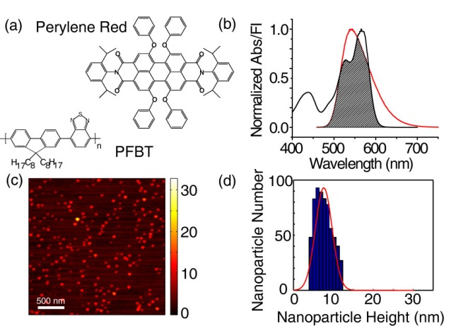

**Fig 1.**  (a) Structures of perylene red and PFBT. (b) Normalized perylene red absorbance (black line) and PFBT fluorescence (red line) in THF with spectral overlap region shaded. (c,d) Representative AFM image of undoped PFBT CPNs and particle size histogram.

Energy transfer efficiency is determined by the ratio of peak donor fluorescence intensities obtained from spectra at various doping percentages, given by

. (1)

Energy transfer as high as 86% is observed with as little as 2% perylene red dopant. The high energy transfer efficiency at low doping ratios is evidence that most of the dye is incorporated in the CPNs, rather than dissolved in the water, as expected, due to the hydrophobic character of the dye. The spectra show that the intensity of acceptor emission in the doped samples increases as dopant is added up to 0.5% doping. Upon further doping, acceptor emission intensity decreases. This is hypothesized to be due to aggregation quenching of the acceptor within the nanoparticle as dye dimers begin to form. This also accounts for the red shift of the acceptor emission as doping increases. Stern-Volmer quenching analysis yields a quenching constant of 37 per molecule, indicating that roughly 37 PFBT molecules are quenched by a single perylene red dye. From this result, the effective quenching radius of a single perylene red dye has been calculated to be 5.3 nm, which will be revisited in the modeling discussion later. The quantum yield of undoped PFBT CPNs was measured to be 0.14 using fluorescein in 0.01 M NaOH as a standard, which is consistent with prior measurements.6,40 The total fluorescence quantum yield of the doped samples decreases with increasing perylene red dopant and follows a roughly linear trend. Therefore, doping with perylene red alone does not increase the brightness of PFBT CPNs (c.f. Fig 2). However, at moderate doping levels (0.5%-1%), the decrease in fluorescence quantum yield is not substantial, while the energy transfer efficiency is high.

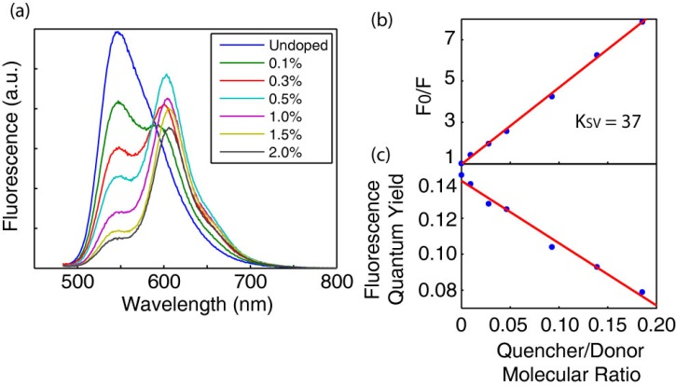

**Fig 2.** (a) Fluorescence spectra of perylene red doped PFBT CPNs at various doping ratios. (b) Stern-Volmer quenching plot. (c) Total fluorescence quantum yield vs. quencher-donor molecular ratio.

**Picosecond time-resolved fluorescence spectroscopy.** A key component to understanding exciton dynamics in CPNs is the measurement of the distribution of exciton lifetimes. Time-correlated single photon counting (TCSPC) is an invaluable method for determining lifetimes on the sub-nanosecond time scale. The apparatus employed is described in the previous section. The resulting decay trace is fit by a least-squares minimization procedure involving convolution of a trial decay function with the instrument response function. The trial functions are (single) exponential, bi-exponential, and the stretched exponential or Kohlrausch-Williams-Watts (KWW) function,

. (4)

The KWW function includes a stretch-parameter ß, which acts as a measure of lifetime heterogeneity, ranging between ~0.2 and 1, where lower values indicate a broad distribution of lifetimes while ß = 1 corresponds to a single exponential.41The fluorescence decay of PFBT in THF fit well to a single exponential, while the decays of undoped nanoparticles and lightly to moderately-doped particles (0.1%-1.0%) exhibited complex decay kinetics that fit well to both bi-exponential and stretched exponential (KWW) functions. While single exponential fits converged for all samples, bi-exponential and KWW fits did not converge for 1.5% and 2% doping due to low signal levels and short lifetimes. Results show a decreasing trend in lifetimes with a slight decreasing trend in beta (c.f. Fig 3). The decreasing trend in beta corresponds to increasing heterogeneity, or a broader distribution of exciton lifetimes as doping increases. The observed increase in heterogeneity agrees qualitatively with the physical picture of exciton diffusion and energy transfer, which will be discussed below.

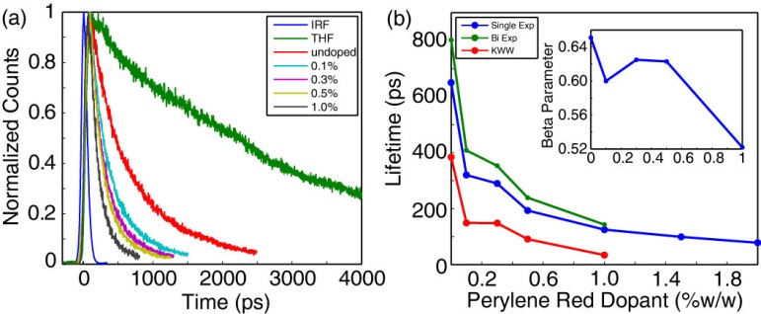

**Fig 3.** (a) Normalized fluorescence lifetime decay traces for PFBT in THF and doped CPNs. (b) Single exponential (blue), bi-exponential weighted average (green), and KWW (red) lifetimes of perylene red doped CPNs. Inset: KWW heterogeneity parameter ß vs. perylene red dopant percent.

**Exciton Diffusion Energy Transfer Model.** A number of experimental observations as well as arguments based on theoretical considerations indicate that excitons in conjugated polymers can hop from chromophore to chromophore in a random, diffusion-like process prior to decaying or undergoing energy transfer to a defect or dopant molecule.42-44 The dynamics of these processes can be modeled by way of a random walk algorithm, yielding predicted values for energy transfer efficiency.22 Several changes have been made to the simulation code. We have recently extended the simulation code to provide the distribution of exciton lifetimes. Also, rather than generating fluorescence decay traces by tracking the times when individual excitons decay, the exciton population as a function of time is used to generate a fluorescence decay trace. Additionally, instead of propagating excitons on a cubic lattice, the generated excitons are propagated from time  to time  and position  to position  where the change in position is a Gaussian distributed random number

. (5)

The variance is defined as

, (6)

where  is the one-dimensional exciton diffusion constant and  is the time step size in ps (including equivalent expressions for y and z positions). By comparing the simulation results to experimental results for energy transfer efficiency and fluorescence lifetime, it is possible to determine values such as the exciton diffusion length

, (7)

where n is the dimensionality (n = 3), D is the three-dimensional exciton diffusion constant and is the fluorescence lifetime of the polymer in good solvent.

It is hypothesized that quenching by defects in the polymer occurs upon nanoparticle formation in undoped CPNs, as evidenced by several observations. First, the fluorescence quantum yield and excited state lifetime of the nanoparticles is greatly reduced ( = 0.14,  = 800 ps) as compared to PFBT in THF ( = 0.66,  = 3000 ps). Secondly, the heterogeneity of the excited state lifetime of the nanoparticle is increased (ß = 0.65) as compared to the free polymer in solution (ß = 1.0). Lastly, the radiative rate, calculated by

, (x)

is not substantially reduced in the nanoparticles (1.8x108 s-1), compared to the polymer in THF (2.2x108 s-1), which rules out dipole-coupling in aggregates as the principal cause of the change in lifetime, and thus favors the defect quenching hypothesis. In order to account for this hypothesis in the simulation, the average number of defects per nanoparticle (expressed in dye equivalents) has been added as a model parameter.

Preliminary simulation results (in the Supporting Information) indicate that the use of the random walk algorithm in the absence of defect quenching was found to be insufficient to adequately match experimental lifetimes and beta values of perylene red doped PFBT CPNs despite matching experimental quenching efficiencies well. In order to better match simulated results to experiment, the Poisson distribution of defects dyes has also been implemented into the model, which is described fully in the Supporting Information.

The initial exciton diffusion simulations were carried out for a particle of radius 4 nm, as was determined by AFM (c.f. Fig. 1), the exciton diffusion length was set at 12 nm and the time step was set to 1 ps. Initially, a Förster radius of 3 nm was determined from the spectra of perylene red and PFBT in THF using standard methods.45 However, the resulting Poisson weighted fluorescence decays did not match experimental quenching efficiencies very well. It is hypothesized that there is some uncertainty in the exact quantity of the orientation factor 

 , (10)

where  is the angle between the donor emission transition dipole and the acceptor absorption transition dipole,  and  are the angles between the donor emission transition dipole and the acceptor absorption transition dipole with the vector joining the donor and acceptor, respectively.45 Therefore, it was assumed that the quantity of 3 nm for R0 has some room for minor alteration as a simulation parameter due to uncertainty as to whether or not , a question that will be addressed in future experiments. Thus, simulations were carried out using an increased R0 of 4 nm.

Another detail which must be accounted for in the Poisson weighted fluorescence simulations is matching the quantum yield and lifetime reductions observed upon nanoparticle formation. This quenching is due to defects introduced upon chain collapse as the solvent medium abruptly shifts to a poor solvent. Exciton diffusion—which is also hypothesized to be introduced upon chain collapse, allows singlet excitons to migrate to nearby defects, thus dramatically enhancing quenching by even a small number of defects per nanoparticle comprised of many chromophores. The first data point in each of the plots resulting from the analysis of the Poisson distributed fluorescence decays is calculated by setting  to zero and increasing  until the experimental quenching efficiency of the defects introduced by nanoparticle formation was matched, which is calculated by

, (11)

which is ~0.79 for PFBT. The values for  are calculated by determining the number of PFBT molecules per nanoparticle (~16 molecules per nanoparticle) and multiplying by the quencher/donor molecular ratio

, (12)

where and  are the average number of perylene red dyes and PFBT molecules per nanoparticle, respectively (calculated for each sample of doped CPNs). By utilizing the lifetime and quenching efficiency results of the nanoparticles at various doping levels as well as the polymer in good solvent, we are able to probe the relative contributions of energy transfer and quenching by defects on the exciton diffusion length. The results of fitting to the Poisson distributed fluorescence decays are given in Fig. 6.

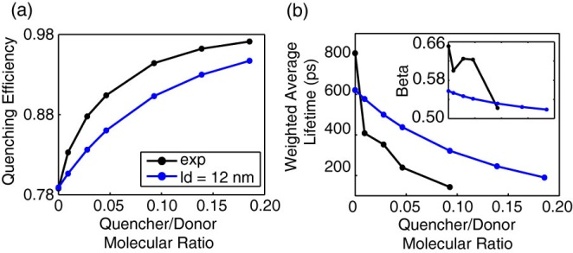

**Fig. 6.** (a) Poisson weighted average quenching efficiency, (b) bi-exponential weighted average lifetime, and beta (inset) obtained from fitting results of Poisson weighted average fluorescence decays. The Poisson weighted results calculated from exciton diffusion data (blue) are compared to TCSPC results (black).

It was determined by matching the quenching efficiency to Equation 11 that the average number of defects introduced into the nanoparticle upon formation is equal to 2.3 perylene red dye equivalents per nanoparticle. By introducing the Poisson distribution of defects and dyes, there is a trade-off in the accuracy in fit to quenching efficiency for greater accuracy in lifetimes and particularly beta. Nevertheless, the simulated data fits reasonably well to all parameters. The exciton diffusion length of 12 nm is similar to that obtained for low temperature measuremnts of dye-doped polyfluorene films determined by analyzing acceptor emission intensity as a function of acceptor separation.21 This result has implications for polymer-based photovoltaics, since the exciton diffusion length is roughly a factor of ~4 lower than the optical skin depth of the polymer.

It is evident from Stern-Volmer calculations that the 5.3 nm quenching radius of perylene red (which is higher than R0 even including favorable assumptions) indicates the coupling of exciton diffusion with energy transfer. Lifetime measurements including beta are also clear indicators of the effect of exciton diffusion in the system. The dramatic reduction lifetime in undoped PFBT CPNs as well as the reduction in beta from 1.0 for PFBT in THF to ~0.6 for PFBT CPNs supports the notion that exciton migration is occurring due to the broadening of the distribution of exciton lifetimes upon nanoparticle formation. Results of exciton diffusion simulations (given in the Supporting Information) indicate that an increase in either LD or R0 results in an increase in quenching efficiency. As such, matching simulated and experimental quenching efficiencies alone is insufficient to separate the individual contributions of exciton diffusion and energy transfer in this system. The simulated lifetimes are directly proportional to (1-QE), as expected. While an exact function is not known in order to calculate beta directly from the simulated LD and R0, simulation trends indicate that beta is directly proportional to LD and inversely proportional to R0. Thus, beta is proportional to the ratio of LD/R0. This suggests that the Förster radii calculated in our previous work on dye-doped polyfluorene CPNs, which did not include fitting to KWW, were likely underestimated.22 Therefore, the combined approach of measuring lifetimes (and beta), quenching efficiency data, and modeling is necessary in order to disentangle the effects of exciton diffusion and energy transfer.

**Conclusions**

Perylene red doped PFBT CPNs were prepared by reprecipitation, and undergo efficient energy transfer from PFBT to perylene red at low doping percentages. The fluorescence characteristics of the dye doped CPNs were studied by steady state and time-resolved fluorescence methods. The spectra are red-shifted significantly with only minor losses in fluorescence quantum yield. The lifetimes of the nanoparticle samples are reduced as doping increases. The distribution of exciton lifetimes was measured to increase as doping increases, as evidenced by a decreasing trend in KWW beta parameter. A combined exciton diffusion/energy transfer model coupled with Poisson statistics was utilized to determine the exciton diffusion length of 12 nm for PFBT CPNs.

**References**

(1) Dennler, G., and Sariciftci, N. S. *P Ieee* **2005**, *93*, 1429.

(2) Yim, K. H., Zheng, Z., Liang, Z., Friend, R. H., Huck, W. T. S., and Kim, J. S. *Adv Funct Mater* **2008**, *18*, 1012.

(3) Wu, C. F.; Szymanski, C.; Cain, Z.; McNeill, J. *J Am Chem Soc* **2007**, *129*, 12904.

(4) Yu, J., Wu, C. F., Sahu, S. P., Fernando, L. P., Szymanski, C., and McNeill, J. *J Am Chem Soc* **2009**, *131*, 18410.

(5) Wu, C. F., Bull, B. Christensen, K. and McNeill, J. *Angewandte Chemie* **2009**, *48*, 2741.

(6) Wu, C. F.; Bull, B.; Szymanski, C.; Christensen, K.; McNeill, J. *ACS Nano* **2008**, *2*, 2415.

(7) Wu, C. F.; Schneider, T.; Zeigler, M.; Yu, J. B.; Schiro, P. G.; Burnham, D. R.; McNeill, J. D.; Chiu, D. T. *J Am Chem Soc* **2010**, *132*, 15410.

(8) Wu, C. F.; Chiu, D. T. *Angew Chem Int Edit* **2013**, *52*, 3086.

(9) Koner, A. L.; Krndija, D.; Hou, Q.; Sherratt, D. J.; Howarth, M. *ACS Nano* **2013**, *7*, 1137.

(10) Emelianova, E. V., Athanasopoulos, S., Silbey, R. J., and Beljonne, D. *Phys Rev Lett* **2010**, *104*, 206405.

(11) Kasha, M.; Rawls, H. R.; Ashraf El-Bayoumi, M. *Pure and Applied Chemistry* **1965**, *11*, 371.

(12) Lunt, R. R., Giebink, N. C., Belak, A. A., Benzinger, J. B., and Forrest, S. R. *Journal of Applied Physics* **2009**, *105*, 053711.

(13) Gammill, L. S.; Powell, R. C. *Mol Cryst Liq Cryst* **1974**, *25*, 123.

(14) Powell, R. C.; Kepler, R. G. *B Am Phys Soc* **1969**, *14*, 866.

(15) Scholes, G. D., and Rumbles, G. *Nature Materials* **2006**, *5*, 683.

(16) Burkalov, V. M., Kawata, K., Assender, H. E., Briggs, G. A. D., Ruseckas, A., and Samuel, I. D. W. *Physical Review B* **2005**, *72*, 075206.

(17) Gregg, B. A., Sprague, J. and Peterson, M. W. *Journal of Physical Chemistry B* **1997**, *101*, 5362.

(18) Donati, D.; Williams, J. O. *Mol Cryst Liq Cryst* **1978**, *44*, 23.

(19) Mulder, B. J. *Philips Res Rep* **1967**, *22*, 142.

(20) Simpson, O. *Proceedings of the Royal Society of London* **1957**, *238*, 402.

(21) Lyons, B. P., and Monkman, A. P. *Physical Review B* **2005**, *71*, 235201.

(22) Wu, C. F., Zheng, Y. L., Szymanski, C., and McNeill, J. *Journal of Physical Chemistry C* **2008**, *112*, 1772.

(23) Tousek, J.; Touskova, J.; Remes, Z.; Kousal, J.; Gevorgyan, S. A.; Krebs, F. C. *Synthetic Met* **2012**, *161*, 2727.

(24) Jelly, E. E. *Nature (London)* **1936**, *139*, 631.

(25) Hayer, A., Van Regemorter, T., Höfer, B., Mak, C. S. K., Beljonne, D., and Köhler, A. *Journal of Polymer Science Part B: Polymer Physics* **2012**, *50*, 361.

(26) Hofmann, S.; Rosenow, T. C.; Gather, M. C.; Lussem, B.; Leo, K. *Physical Review B* **2012**, *85*.

(27) Kelbauskas, L.; Bagdonas, S.; Dietel, W.; Rotomskis, R. *Journal of Luminescence* **2003**, *101*, 253.

(28) McNeill, J. D.; O'Connor, D. B.; Barbara, P. F. *J Chem Phys* **2000**, *112*, 7811.

(29) Adams, D. M.; Kerimo, J.; O'Connor, D. B.; Barbara, P. F. *Journal of Physical Chemistry A* **1999**, *103*, 10138.

(30) Credo, G. M.; Carson, P. J.; Winn, D. L.; Buratto, S. K. *Synthetic Met* **2001**, *121*, 1393.

(31) Powell, R. C.; Kepler, R. G. *Phys Rev Lett* **1969**, *22*, 636.

(32) Marciniak, H.; Teicher, M.; Scherf, U.; Trost, S.; Riedl, T.; Lehnhardt, M.; Rabe, T.; Kowalsky, W.; Lochbrunner, S. *Physical Review B* **2012**, *85*.

(33) Bolinger, J. C.; Traub, M. C.; Adachi, T.; Barbara, P. F. *Science* **2011**, *331*, 565.

(34) Yu, J., Wu, C. F., Tian, Z. and McNeill, J. *Nano Lett* **2012**, *12*, 1300.

(35) McNeill, J. D.; Kim, D. Y.; Yu, Z. H.; O'Connor, D. B.; Barbara, P. F. *Journal of Physical Chemistry B* **2004**, *108*, 11368.

(36) McNeill, J. D.; Barbara, P. F. *Journal of Physical Chemistry B* **2002**, *106*, 4632.

(37) Deussen, M.; Scheidler, M.; Bassler, H. *Synthetic Met* **1995**, *73*, 123.

(38) Szymanski, C., Wu, C. F., Hooper, J., Salazar, M. A., Perdomo, A., Dukes, A., and McNeill, J. *Journal of Physical Chemistry B* **2005**, *109*, 8543.

(39) Campoy-Quiles, M.; Heliotis, G.; Xia, R. D.; Ariu, M.; Pintani, M.; Etchegoin, P.; Bradley, D. D. C. *Adv Funct Mater* **2005**, *15*, 925.

(40) Tian, Z., Yu, J., Wu, C. F., Szymanski, C. and McNeill, J. *Nanoscale* **2010**, *2*, 1999.

(41) Chen, R. *Journal of Luminescence* **2003**, *102*, 510.

(42) Tvingstedt, K., Vandewal, K., Zhang, F., and Inganäs, O. *Journal of Physical Chemistry C* **2010**, *114*, 21824.

(43) Simas, E. R., Gehlen, M. H., Pinto, M. F. S., Siquiera, J., and Misoguti, L. *Journal of Physical Chemistry A* **2010**, *114*, 12384.

(44) Dykstra, T. E., Hennebicq, E., Beljonne, D., Gierschner, J., Claudio, G., Bittner, E. R., Knoester, J., and Scholes, G. D. *Journal of Physical Chemistry B* **2009**, *113*, 656.

(45) Lakowicz, J. R. *Principles of Fluorescence Spectroscopy*; Third ed.; Springer Science+Business Media, LLC: New York, 2006.